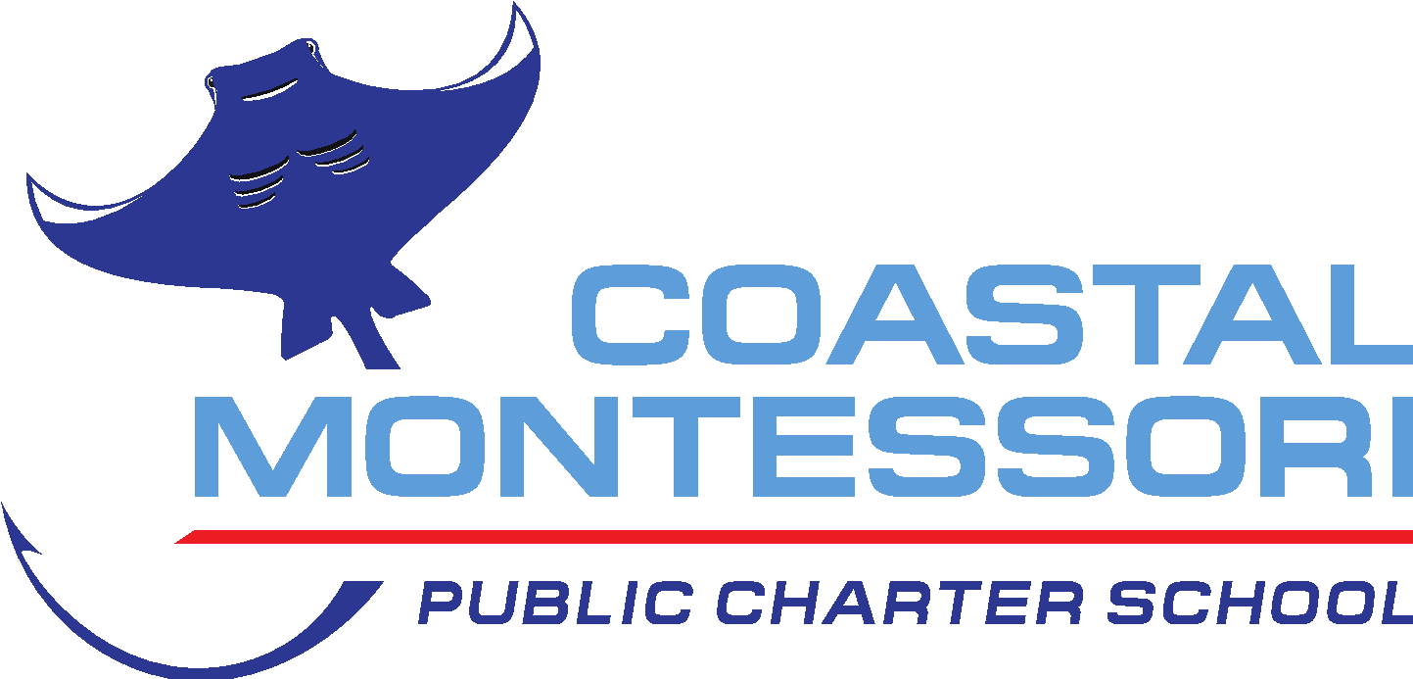
MEETING – BOARD OF DIRECTORS
April 14, 2025, 6:00 p.m.
In-Person at
Coastal Montessori Charter School
111 Old Plantation Drive, Pawleys Island, SC

- CALL TO ORDER
  - Determination of Quorum
  - Adoption of Agenda
    - Motion made by
    - Seconded by
    - Vote
  - Approval of Minutes
    - Minutes of Mar 17, 2025
      - Motion made by
      - Seconded by
      - Vote

- INFORMATION AND REPORTS
  - Financial Report - Ms. Roxann King, Veris
    - FY 25 Year to Date 5 min
    - Start of FY 26 Budget Discussion ~15 min
Time Line
May BOD Meeting - 1st Reading
June BOD Meeting - 2nd Reading/Adoption
  - PTO Report - Ms. Jessica Dent, President 3 min
  - Director’s Report - Mr. Chris Bergeron, Director 3 min

- PUBLIC COMMENTS: This section of each regularly scheduled Board meeting is reserved for comments to be heard from citizens on any item appearing on the agenda. Also, the time is made available for citizens to make specific requests of the school, offer suggestions, or to raise specific issues for future discussion by the Board. Each speaker has three minutes and must abide by the following parameters: speakers may not ask questions of Board Members, and Board Members may not engage speakers in discussion; disruptive behavior is not permitted; personal attacks aimed at students or staff are not permitted; abusive, obscene, or recklessly defamatory language aimed at any Board Member is not permitted. Persons who wish to address the Board are requested to email Mr. Chris Bergeron at cbergeron@coastalmontessoricharter.org before 5:00 pm on the day of the meeting. The first 10 persons to email Mr. Bergeron expressing a desire to speak will be permitted to speak during the meeting.

- EXECUTIVE SESSION
No Session

- ACTION ITEMS

- HOUSEKEEPING ITEMS
  - May Meeting - Induction of New Board Members, Election of Board Officers, Director Contract
  - June Meeting. Update of Policies and Procedures
  - Board Retreat - Saturday, June 21, 2025

- ADJOURNMENT
  - Motion made by
  - Seconded by
  - Vote

- NEXT SCHEDULED MEETING: May 19, 2025 at 6 pm

**Please note that the Board may elect to take action on issues discussed during Executive Session prior to adjournment.
CMCS’s Mission is to produce highly-educated, self-directed, socially-responsible citizens who work collaboratively, respectfully, and peacefully as individuals yet interdependent learners in a diverse and nurturing community. Through the unique combination of empirically validated Montessori principles, localized charter governance, and open access, Coastal Montessori Charter School further aims to provide Georgetown County School District with an academically excellent, financially accountable public-school choice.

